
GRADE 12 2025 / 2026

Methodology: - Burlington Skills for Bachillerato 2 Student’s & Online Workbook / school moodle

Contact: mirian.ansotegi@begonazpi.eus

3rd TERM: Feb 11th – April 27th

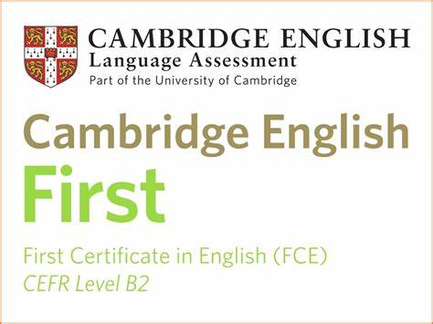
FCE Internal Level Exam:
THURSDAY MARCH 12th

CLASS TIME / YOUR CLASSROOM / At 08.45, be in your classroom

08.45 – 09.40 LISTENING (40-45 mins): / 10%
break
09.50 – 11.20 READING & USE OF ENGLISH (1 hr 15 mins): Reading / 15% & Use of English / 10%

WRITING EXAM: / 30% (160-word Opinion Essay 1/2)

2B/2D TUESDAY MARCH 24th
2E/2A WEDNESDAY MARCH 25th

CLASS TIME / YOUR CLASSROOM

USE OF ENGLISH: / 35%

Week of the 27th of APRIL
tba / YOUR CLASSROOM

UNITS Pre-Unit 1/2/3/4/5/6 + anything seen in class

-Review of ALL Verb Tenses
-Adjectives
-Prepositions & Prepositional Phrases
-Common Expressions
-Collocations
-Idioms
-Modals (sentence transformations)
-Reported Speech (sentence transformations)
-Lexicon: Health / Entertainment / Work & Jobs

Every Single Term:

-correct grammar usage
-sentence transformations
-word building /30 points
-use of linkers by means of sentence transformations /20 points
-phrasal verb recognition and usage (B2 level) /30 points (GRADE 11 & 12)

% BREAKDOWN

/ 30% WRITING
/ 10% LISTENING
/ 15% READING & /10% USE OF ENGLISH

APRIL
/ 35% GRAMMAR & VOCABULARY

-EFFORT (day to day work)
-ENGLISH USAGE
-HOMEWORK
-IN CLASS WORK
-PARTICIPATION
-WORK ETHICS

-------------------------------------------
/ 100% TOTAL

*Bear in mind that a 4.9 is a 4 other than in the Globalak and Bigarren Deialdia

